User guide:

1. Enter your username and password. Please ensure both fields are filled.
2. Choose the action you wish to perform (those who entered an admin username and password will see additional actions).
3. Fill out the fields that appear. Please not that where you see **or**, do **not** fill out both forms, otherwise the website will default to the dropdown list.

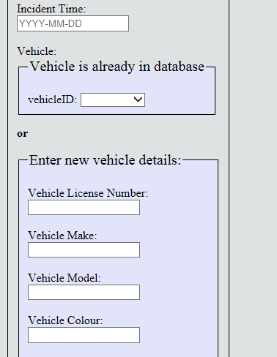

1. Admin forms appear on the right side of the page in red.
2. Hit submit.
3. You will be directed to the results page. If the query was successful, you will see the result. If not, you will see an error message. In case of an error message, please go back and ensure all fields are filled out and you have not mistyped any information.